**DEEPER LIFE HIGH SCHOOL**

**SCHEME OF WORK**

**FIRST TERM E-LEARNING NOTE CLASS: JSS 1 (BASIC 7)**

**SUBJECT: COMPUTER STUDIES**

**WEEK TOPIC**

1. **Historical Development of Computers**: (a) Early counting devices (fingers, stones, sticks, pebbles, cowries, etc.)
2. **Historical Development of Computers**: (b) Mechanical counting and calculating devices: Abacus, Slide rule, Napier’s bone among others.
3. **Historical Development of Computers:** (c) Electro-mechanical counting devices: Wilhelm Schickard ,Tito Livio Burattini,  [Samuel Morland](https://en.wikipedia.org/wiki/Samuel_Morland), [René Grillet](https://en.wikipedia.org/wiki/Ren%C3%A9_Grillet_de_Roven), Blaise Pascal machine and Gottfried Wilhelm (Von)Leibniz
4. **Historical Development of Computers:** (d) Electro-mechanical counting devices: Charles Babbage analytical machine, Philip Emeagwali and Joseph Jacquard’s loom.
5. **Historical Development of Computers:** (e) Electronic counting devices and modern computer: (i) Herman Hollerith punch cards (f) John Von Neumann machine (g) Modern machines.
6. **Historical Development of Computers:** (h) Generations of computers: first, second, third, fourth, fifth.
7. **Mid Term Holiday**
8. **Data processing:** (a) Definition (b) Data processing cycle: data gathering, data collection, input stage, processing stage, storage stage, output stage.
9. **Data Processing:** (c) Importance of computer as a tool for processing data: increased accuracy, efficient storage facilities, and fast access to information and handles repetitive tasks.
10. **Revision**

**11-13.Examination**

**REFERENCES:**

* **HiiT Plc (2016) Computer Studies for Junior Secondary Education (JS1), HiiT Publisher, Nigeria Computer Society (NCS).**
* **Basic Science and Technology: Computer Studies for Junior Secondary Schools 1 by Wole Olatokun et al**
* **Searchlights on Computer Studies for JSS, Bk 1 by Kayode Owolabi et al**

**WEEK 1**

**TOPIC: HISTORICAL DEVELOPMENT OF COMPUTERS**

**CONTENT:**

**Early counting devices (Definition and Examples)**

**Early counting devices are devices that were used in the early days to perform arithmetic operations such as addition of numbers, subtraction and multiplication. These devices were used for the usual barter trade of the early days.**

**Examples of early counting devices are fingers, toes, stones, sticks, pebbles, cowries among others.**

The history and development of computer can be traced back to the studies of Mathematics which started with counting. The history of Mathematics is the history of civilization.

These has led to various computing inventions in search for a tool that could enable man meet his computational and data processing needs until we have the computer today.

It was in the process of finding solutions to the problem of counting that early counting devices emerged. Examples of fingers and toes method of calculation are seen below;

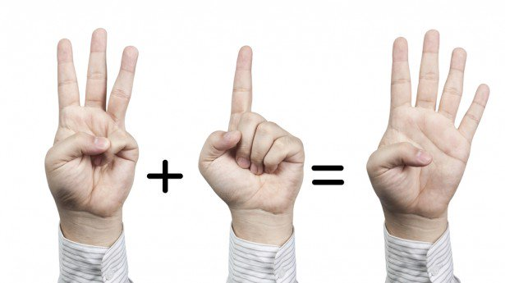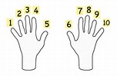

As time went on, fingers and toes method became ineffective, especially for large numbers, hence, the emergence of counting and solving basic arithmetic problems with the use of stones and sticks.

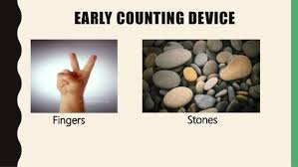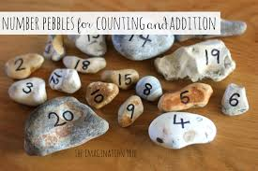

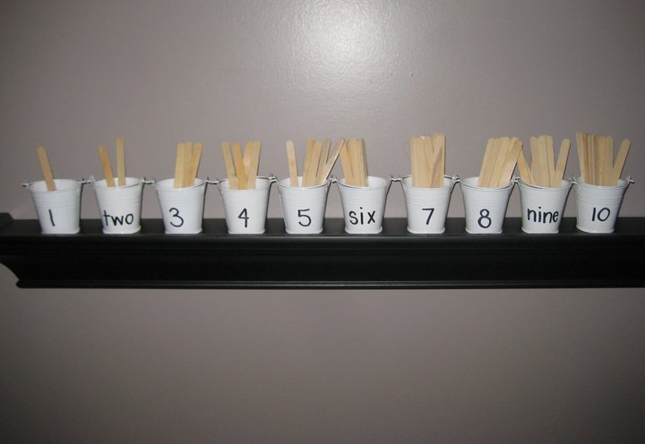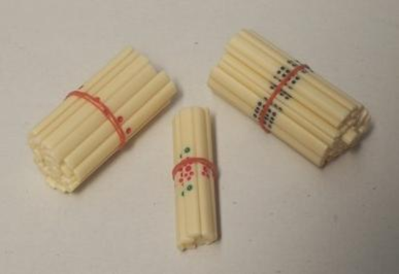

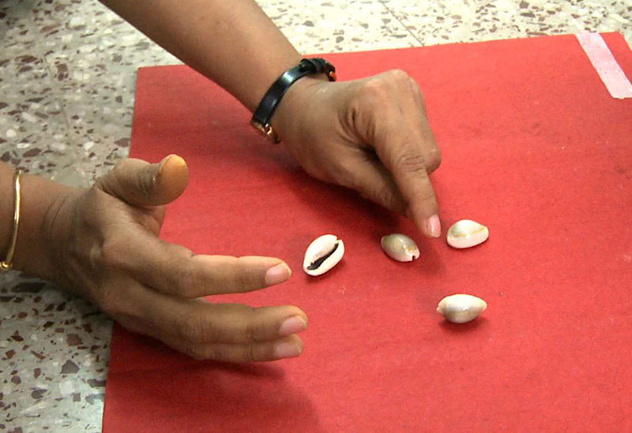

Limitations to the Early Counting Devices

The problems posted by these early counting and data processing method were enormous.

1. They could not be used for counting large numbers efficiently.
2. It is stressful
3. It required man power
4. It is time consuming
5. It requires more of that device to perform a large number of counting

**EVALUATION:**

1. Define early counting devices?
2. Mention four early counting devices.

**READING ASSIGNMENT:**

Study the topic ‘Mechanical Counting devices’ using your students’ textbook

**WEEKEND ASSIGNMENT:**

Write a brief history of Abacus

**WEEK 2**

**TOPIC: HISTORICAL DEVELOPMENT OF COMPUTERS**:

**CONTENT:**

**Mechanical counting/calculating devices**

As a result of the disadvantages of the early counting devices, more advanced mechanical counting/calculating devices were invented. Some of these devices are;

* Abacus (Chinese)
* Napier’s Bone (John Napier)
* Slide Rule (William Oughtred)

**THE ABACUS**

The Abacus is made up of beads threaded on iron rods. The iron rods are fixed to a rectangular wooden frame. It is used for addition and subtraction only. It could not carry out complex mathematics. The Abacus was early used for arithmetic tasks, it was developed in China about 5000 years ago. It was successful that its use spread from china to many other countries.

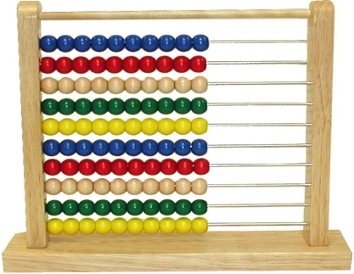

**NAPIER’S BONE**

After the Abacus, the next significant development was Napier’s Bone by John Napier in 1617. John Napier was a Scottish [mathematician](https://en.wikipedia.org/wiki/Mathematics), [physicist](https://en.wikipedia.org/wiki/Physicist), and [astronomer](https://en.wikipedia.org/wiki/Astronomer). He is best known as the discoverer of [logarithms](https://en.wikipedia.org/wiki/Logarithm). He also made common the use of the [decimal point](https://en.wikipedia.org/wiki/Decimal_point) in arithmetic and mathematics. Napier's bone is a manually-operated calculating device for [calculation](https://en.wikipedia.org/wiki/Calculation) of products and [quotients](https://en.wikipedia.org/wiki/Quotient) of numbers.

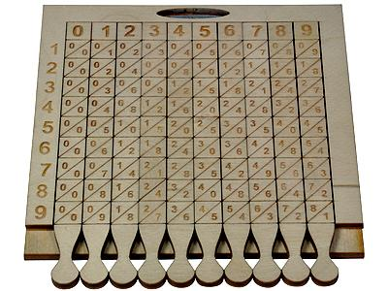

Using the multiplication tables embedded in the rods, multiplication can be reduced to addition operations and division to subtractions. More advanced use of the rods can even extract [square roots](https://en.wikipedia.org/wiki/Square_root). Note that Napier's bone is not the same as [logarithms](https://en.wikipedia.org/wiki/Logarithm), with which Napier's name is also associated. The complete device usually includes a base board with a rim; the user places Napier's rods inside the rim to conduct multiplication or division. The board's left edge is divided into 9 squares, holding the numbers 1 to 9. The Napier's rod consists of strips of wood, metal or heavy cardboard. Napier's bone is three-dimensional, square in cross section, with four different rods engraved on each one. A set of such bones might be enclosed in a convenient carrying case.

**SLIDE RULE**

The slide Rule which is also called the **slip-stick** in the United States of America was invented around 1620-1630 shortly after John Napier’s publication of the concept of logarithms. It is a mechanical analogue computer. The slide rule is used primarily for multiplication, division, and also functions such as roots, algorithms and trigonometry, **but is not normally used for addition or subtraction.**

Slide rules come in diverse range of styles and generally appear in a straight or circular form with a standardized set of markings (scales) essential to performing mathematical computations.

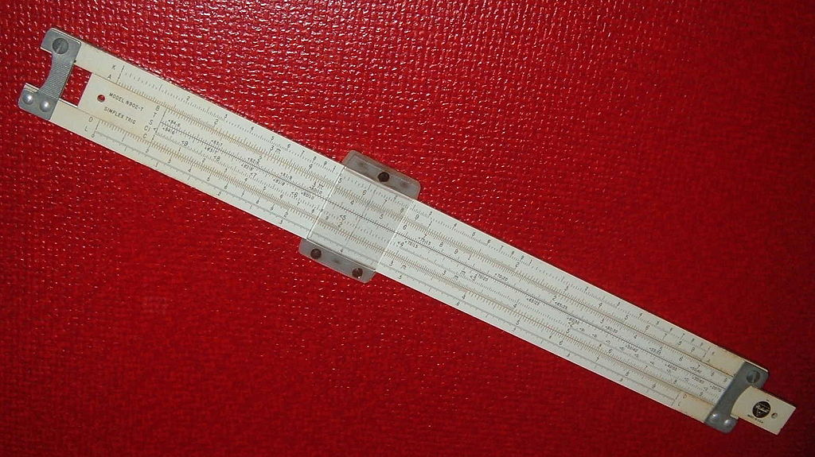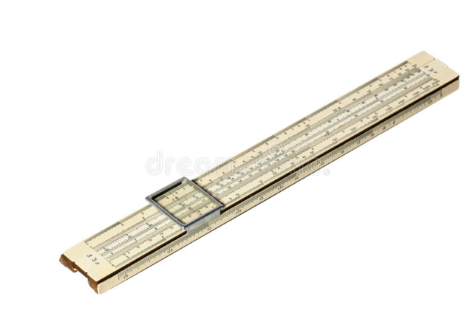

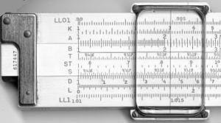

The use of slide rule continued to grow through the 1950s and 1960s even as digital computing devices were being gradually introduced.

**EVALUATION**

1. Mention two examples of mechanical counting/calculating devices
2. Who invented the Speeding clock?
3. To perform Multiplication on the Speeding clock, _____was added to it
4. The slide rule was invented by________
5. Another name for Slide Rule is_________

**READING ASSIGNMENT**

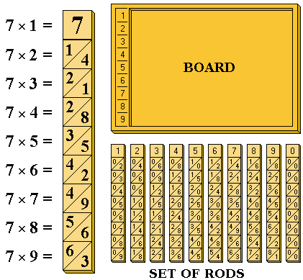Read on Electro-mechanical counting devices

**WEEKEND ASSIGNMENT**

1. How old was Blaise Pascal when he invented the Pascaline?
2. Why did Blaise Pascal invent the Pascaline?
3. List out two machines invented by Charles Babbage
4. Describe the following: (i) Abacus (ii) Slide rule (iii) Calculating clock

**WEEK: 3**

**TOPIC: HISTORICAL DEVELOPMENT OF COMPUTERS**

**CONTENT: ­**

**Electro-mechanical counting devices:**

(a) Definition and description of electro-mechanical counting devices

(b) Examples of electro-mechanical counting devices

**Sub-topic 1: ELECTRO-MECHANICAL COUNTING DEVICES**

These are counting devices that could be operated both electrically and mechanically. Electro-mechanical devices include the following:

1. Speeding Clock
2. Blaise Pascal machine
3. Gottfried Leibniz Machine

**SPEEDING CLOCK OR CALCULATING CLOCK**

In 1623 and 1624, reported his design and construction of what he referred to as an arithmetical instrument that he has invented but which would later be described as a (calculating clock). The machine was designed to assist in all the four basic functions of arithmetic (addition, subtraction, multiplication and division). Amongst its uses, Schickard suggested it would help in the laborious task of calculating astronomical tables. **The machine could add and subtract six-digit numbers, and indicated an overflow of this capacity by ringing a bell.** The adding machine in the base was primarily provided to assist in the difficult task of adding or multiplying two multi-digit numbers. To this end an ingenious arrangement of rotatable Napier's bones were mounted on it. It even had an additional "memory register" to record intermediate calculations. Schickard’s machine was not programmable.

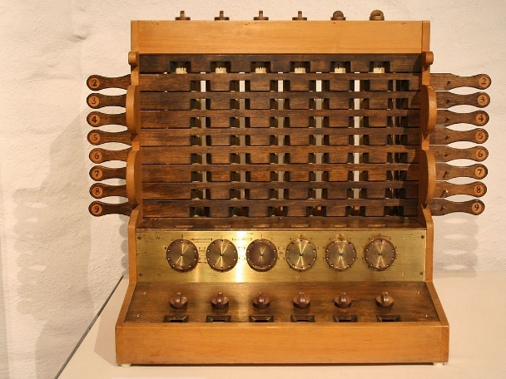

**BLAISE PASCAL’S CALCULATING MACHINE (Pascaline)**

Blaise Pascal was a French man who invented the first true adding machine in 1642. He was a mathematician as well as a philosopher. In 1642, he began working on calculating machines and after 3 years invented the mechanical calculator called Pascaline.

Blaise Pascal was born in France in 1623 and died in Paris in 1662. His machine was based on Abacus principle. The machine was built to assist his father to perform tedious tax accounting (auditing of government tax accounts). The machine was invented when he was 19 years old. **He designed the Pascaline to add and subtract two numbers directly and to perform multiplication and division through repeated addition and subtraction.**

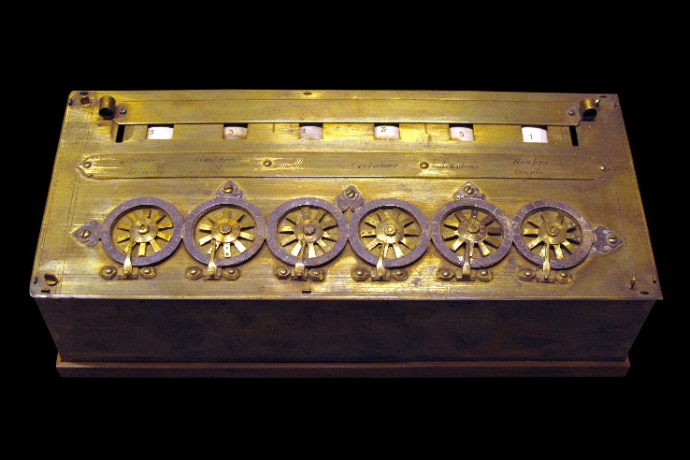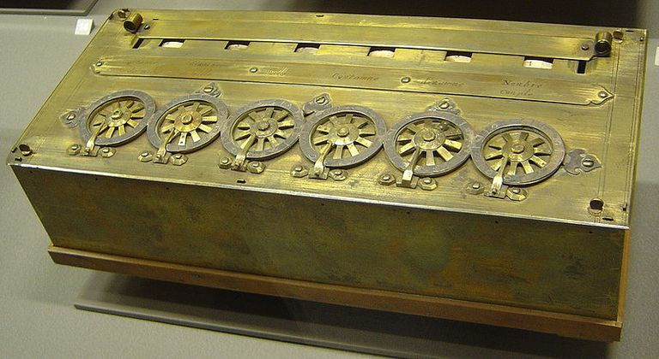

**EVALUATION:**

1. Mention four electro-mechanical counting devices.
2. When was Blaise Pascal adding machine invented?
3. The design of Pascaline was based on which principle?
4. The machine was built to assist his father to perform_______

**SUBTOPIC 2: ELECTRO-MECHANICAL COUNTING DEVICES**

**STEPPED RECKONER:** This machine was invented by Gottfried William Von Leibnitz. he carried out further development on the work of Blaise Pascal so that multiplication and division could be possible directly. He invented a machine called “THE STEPPED RECKONER” in 1694. The machine is a mechanical calculator which can do multiplication, division and calculate square roots. The process of multiplication involved repeated addition. It was the first calculator that could perform all four arithmetic operations (addition, subtraction, multiplication and division).

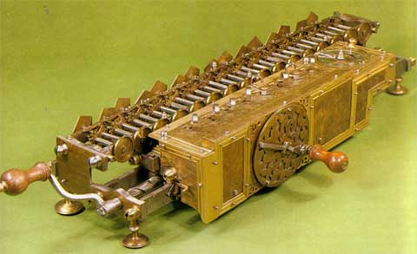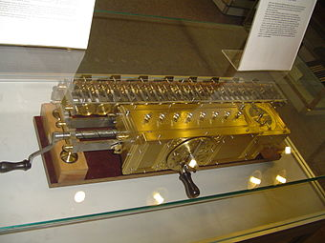

**EVALUATION**

1. Mention four electro-mechanical counting devices.
2. Who invented the Stepped Reckoner and what year?
3. When was Blaise Pascal’s adding machine invented?
4. The design of Pascaline was based on which principle?
5. The machine was built to assist his father to perform_______

**ASSIGNMENT:**

Differentiate between Difference Engine and Analytical Engine developed by Charles Babbage

**WEEK 4:**

**ELECTRO-MECHANICAL COUNTING DEVICES**

**JOSEPH JACQUARD’S LOOM**

The Jacquard machine is a device fitted to a power loom that simplifies the process of manufacturing textiles with such complex patterns as brocade, damask and matelassé. It was invented by Joseph Marie Jacquard in 1804. The loom was controlled by a chain of cards, a number of punched cards, laced together into a continuous sequence. Multiple rows of holes were punched on each card, with one complete card corresponding to one row of the design. The Jacquard loom was the first machine to use punch cards to control a sequence of operations.

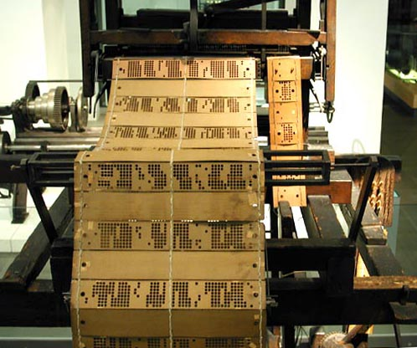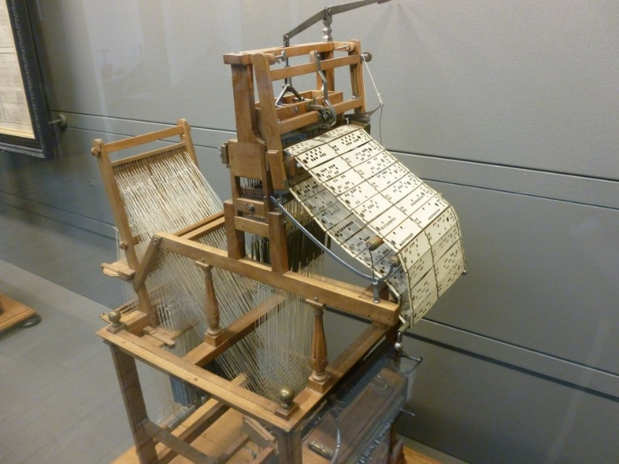

**CHARLES BABBAGE’S MACHINES**

Charles Babbage (26 December 1791 – 18 October 1871) was an English polymath, a mathematician, philosopher, inventor and mechanical engineer. Babbage originated the concept of a digital programmable computer. Babbage is credited with inventing the first mechanical computer that eventually led to more complex electronic designs, though all the essential ideas of modern computers are to be found in Babbage's analytical engine. His varied work in other fields has led him to be described as "pre-eminent" among the many polymaths of his century.

He was the first person to design a computer that is different from a calculator. Charles Babbage is referred to as the father of modern day computers because all his ideas are contained in modern computers.

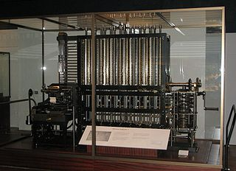

1. **DIFFERENCE MACHINE**

In 1822, Charles Babbage developed the difference machine that could perform intricate calculations correctly and rapidly on the principle that anticipated the modern electronic computer**. A difference engine is an automatic mechanical calculator designed to tabulate polynomial functions.** The name derives from the method of divided differences, a way to interpolate or tabulate functions by using a small set of polynomial coefficients. Most mathematical functions commonly used by engineers, scientists and navigators, including logarithmic and trigonometric functions, can be approximated by polynomials, so a difference engine can compute many useful tables of numbers.

1. **ANALYTICAL ENGINE**

In 1837, the Analytical Engine was developed and it could be programmed. That means it can receive instructions and solve problems given to it. The Analytical Engine was a proposed mechanical general-purpose computer designed by English mathematician and computer pioneer Charles Babbage. It was first described in 1837 as the successor to Babbage's difference engine, a design for a mechanical computer. The Analytical Engine incorporated an arithmetic logic unit, control flow in the form of conditional branching and loops, and integrated memory, making it the first design for a general-purpose computer that could be described in modern terms as Turing-complete. In other words, the logical structure of the Analytical Engine was essentially the same as that which has dominated computer design in the electronic era

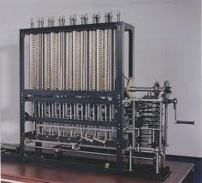

The Analytical Engine had the following parts:

1. A mill for calculation
2. A store for holding instructions, intermediate and final results
3. An operator (or system) for carrying out instruction
4. A device for ‘reading’ and ‘writing’ data on punched card

**EVALUATION:**

1. Mention the two (2) machines invented by Charles Babbage and their years of invention
2. Mention at least four (4) parts that make up an analytical engine
3. Briefly describe the following (i) Jacquard loom (ii) Stepped Reckoner

**SUBTOPIC 2:**

**HOLLERITH CENSUS MACHINE:** Herman Hollerith (February 29, 1860 – November 17, 1929) was an [American](http://en.wikipedia.org/wiki/United_States) [statistician](http://en.wikipedia.org/wiki/Statistician) and [inventor](http://en.wikipedia.org/wiki/Inventor) who developed a mechanical [tabulator](http://en.wikipedia.org/wiki/Tabulating_machine) based on [punched cards](http://en.wikipedia.org/wiki/Punched_card) to rapidly tabulate statistics from millions of pieces of data. He was the founder of the **Tabulating Machine Company** that later merged to become [IBM](http://en.wikipedia.org/wiki/IBM). Hollerith is widely regarded as the father of modern automatic computation. The machine was used to process the information obtained in the census of the population carried out in the united state in 1890. With this machine, he was able to achieve in three years what would take seven years to do manually.

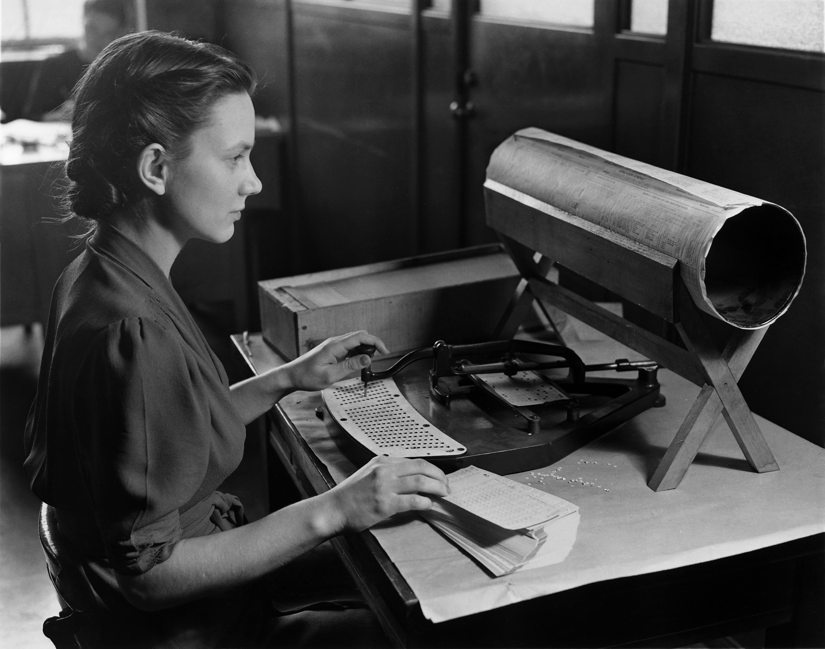 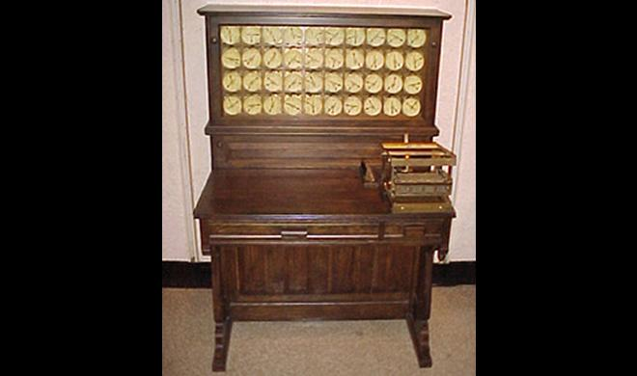

**PHILIP EMEAGWALI**

Dr. Philip Emeagwali, who had been called the Bill Gates of Africa, was born in Akure, Nigeria on 23 August 1954, invented one of the world’s fastest computers. He dropped out of school in 1967 because of the Nigerian-Biafran war**.**

Dr. Philip Emeagwali first entered the limelight in 1989 when he won the prestigious Gordon Bell Prize for his work with massively parallel computers. He programmed the connection machine to compute a world record 3.1 billion calculations per second using 65,536 processors to simulate oil reservoirs. With over 41 inventions, Philip Emeagwali is making big waves in the super computer industry.

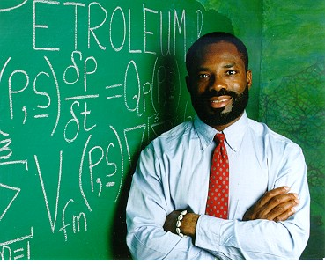

**EVALUATION:**

1. What was the major contribution of Dr Philip Emeagwali to the development of computers

**GENERAL EVALUATION:**

1. List three people who were inventors of electro-mechanical devices and the machine they invented.

2. Why is Charles Babbage referred to as the father of Computer?

**READING ASSIGNMENT:**

Students are to read ‘Electronic Computing Devices’ in the given students’ textbook.

**WEEKEND ASSIGNMENT**

1. Which of the following is NOT an electro-mechanical counting device?

(a) John Napier bone (b) Stepped Reckoner (c) Jacquard Loom (d) Calculating Clock

2. Gottfried Wilhelm Von Leibniz invented a machine known as ________

(a) Adding machine (b) Textile loom (c) Stepped Reckoner (d) Napier bone

3. Which of the following inventors designed a machine with similar elements to modern

digital computers.

(a) Blaise Pascal (b) Charles Babbage (c) John Napier (d) Ada Lovelace

**WEEK 5**

**TOPIC: HISTORICAL DEVELOPMENT OF COMPUTERS:**

**CONTENT: ­**

**ELECTRONIC COUNTING DEVICES AND MODERN COMPUTER**

1. John Von Neumann machine
2. Modern machines

**SUB-TOPIC 1**

**JOHN VON NEUMANN’S MACHINE**

**In 1945, mathematician John von Neumann undertook a study of computation that demonstrated that a computer could have a simple, fixed structure, yet be able to execute any kind of computation given properly programmed control without the need for hardware modification.** Von Neumann contributed a new understanding of how practical fast computers should be organized and built; these ideas, often referred to as **the stored-program technique, became fundamental for future generations of high-speed digital computers and were universally adopted.** The primary advance was the provision of a special type of machine instruction called conditional control transfer which permitted the program sequence to be interrupted and reinitiated at any point, similar to the system suggested by Babbage for his analytical engine and by storing all instruction programs together with data in the same memory unit, so that, when desired, instructions could be arithmetically modified in the same way as data. Thus, data was the same as program.

The von Neumann architecture is a design model for a stored-program digital computer that uses a processing unit and a single separate storage structure to hold both instructions and data. It is named after the mathematician and early computer scientist John von Neumann. The terms "von Neumann architecture" and "stored-program computer" are generally used interchangeably. **A stored-program digital computer is one that keeps its programmed instructions, as well as its data, in read-write, random access memory (RAM).**

His area of interest included:

1. Use of binary codes for representing data and instructions.
2. Use of codes to store both data and instruction together and share the same storage location (space) within the computer
3. Use of computer to process both data and instructions
4. Modification of programs by programs.

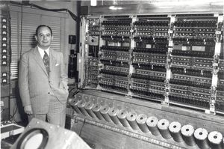

**MODERN COMPUTER**

The invention of electronic computers transformed the mechanical way of processing data into information. Those early pocket calculator were actually the signal of the modern computerized world w have today. Earlier counting was done in base ten; called decimal system. It is also possible to count in base eight, six, two and many more. Electronic computers count in a system based on 0’s and 1’s binary.

**EVALUATION**

1. Enumerate three areas of interest in John Von Neumann concept
2. What is the stored program technique?
3. Briefly discuss the similarity between the works of Charles Babbage and John Von Neumann

**READING ASSIGNMENT:**

Study and make a summary of the topic ‘Generations of Computers’

**WEEKEND ASSIGNMENT:**

Briefly describe the term “modern machines’

**WEEK 6**

**TOPIC: HISTORICAL DEVELOPMENT OF COMPUTERS**

**CONTENT:**

**Generation of Computers: First, second, third, fourth and fifth generations.**

**GENERATIONS OF COMPUTER:**

Generation of computers is the developmental stages that the computer has gone through. There are 5 generations of computers and their accompanying innovations.

**1ST GENERATION**

**1940 – 1956: First Generation – Vacuum Tubes**

First generation computers were those manufactured between 1940s and 1950s. The computers used the stored program concept. First generation computers were associated with the vacuum tubes or valves technology as circuitry and magnetic drums for memory.

**CHARACTERISTICS:**

1. They were very bulky and heavy.
2. They measured between 50 – 100ft long and about 80ft high.
3. The computers weighed up to 200 tons and occupied 3000 cubic ft.
4. They used vacuum tubes to store and process data.
5. Examples of first generation computers are ENIAC, EDSAC, and UNIVAC.
6. It generates a lot of heat
7. It relies on machine language
8. These computers were limited to solving one problem at a time

**PROBLEMS OF FIRST GENERATION COMPUTERS**

1. The vacuum tubes also generated a lot of heat hence, they needed a cooling system.
2. They were very bulky and heavy and are not mobile
3. It occupies excess space
4. It consumes a lot of energy.

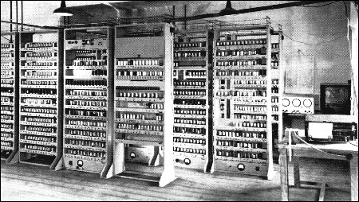

**EDSAC**

**2ND GENERATION TRANSISTOR**

**1956 – 1963: Second Generation – Transistor**

The replacement of vacuum tubes by transistors saw the advent of the second generation of computing. They were a big improvement over the vacuum tube, despite still subjecting computers to damaging levels of heat. However they were hugely superior to the vacuum tubes, making computers smaller, faster, cheaper and less heavy on electricity use. They still relied on punched card for input/printouts.

The language evolved from cryptic binary language to symbolic (assembly) languages. This means, programmers could create instructions in words. About the same time high level programming languages were being developed (early versions of COBOL and FORTRAN). Transistor-driven machines were the first computers to store instructions into their memories – moving from magnetic drum to magnetic core-technology. The early versions of these machines were developed for the atomic energy industry. Examples of second generation computers are NCR, 315, International Business Machine (IBM), 7030.

**CHARACTERISTICS:**

1. They were smaller in size than first generation computers.
2. They occupied smaller space than the first generation computers.
3. Second generation computers used less electricity and generated less heat.
4. The transistors could do all that the vacuum tubes did.
5. The computers were faster and lighter in weight than first generation computers.
6. It uses assembly language
7. It uses punch card for input and output

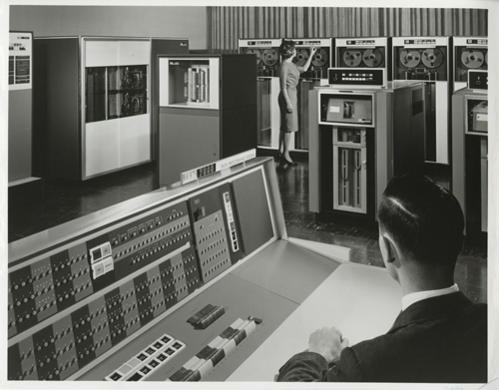

**3RD GENERATION INTEGRATED CIRCUIT** **(IC)**

**1964 – 1971:**

By this phase, transistors were reduced and put on silicon chips (called semiconductors). This led to a massive increase in speed and efficiency of these machines. These were the first computers where users interacts using keyboards and monitors used an operating system. This enabled these machines to run several applications at once using a central program which functioned to monitor memory. As a result of these advances which again made machines cheaper and smaller, a new mass market of users emerged during the 1960s**.** They were first used in space ships and electronic military equipment.

**CHARACTERISTICS:**

1. The computers used integrated circuits.
2. They were faster than second generation computers.
3. They were smaller in size and also more powerful.
4. The computers had fast memory access.
5. It runs several applications at a time.
6. They were first used in space ships and electronic military equipment.

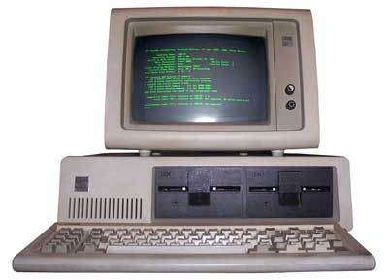

**4TH GENERATION VERY LARGE INTEGRATED CIRCUIT**

**1972 – 1984:**

Intel The chip-maker developed the Intel 4004 chip in 1971, which positioned all computer components (CPU, memory, input/output controls) onto a single chip. What filled a room in the 1940s now fit in the palm of the hand. **The Intel chip housed thousands of integrated circuits.** The year 1981 saw the first ever computer (IBM) specifically designed for home use and 1984 saw the Macintosh introduced by Apple. Microprocessors even moved beyond the realm of computers and into an increasing number of everyday products.

The increased power of these small computers meant they could be linked, creating networks which ultimately led to the development, birth and rapid evolution of the Internet. **Other major advances during this period have been the Graphical user interface (GUI), the mouse and more recently the astounding advances in lap-top capability and hand-held devices.**

**A microprocessor is a central processing unit fabricated on a chip.** This generation of computers had optical readers and graphic display terminals. The use of floppy diskette as a storage facility was introduced in this generation. **Examples are Intel 4004, Intel 8085, Pentium 1, 2, 3, etc**

**CHARACTERISTICS:**

1. The computers were smaller in size
2. They were very powerful computers
3. They had high processing speed
4. They had high storage capacity
5. They use Graphical User Interface (GUI)
6. They use mouse

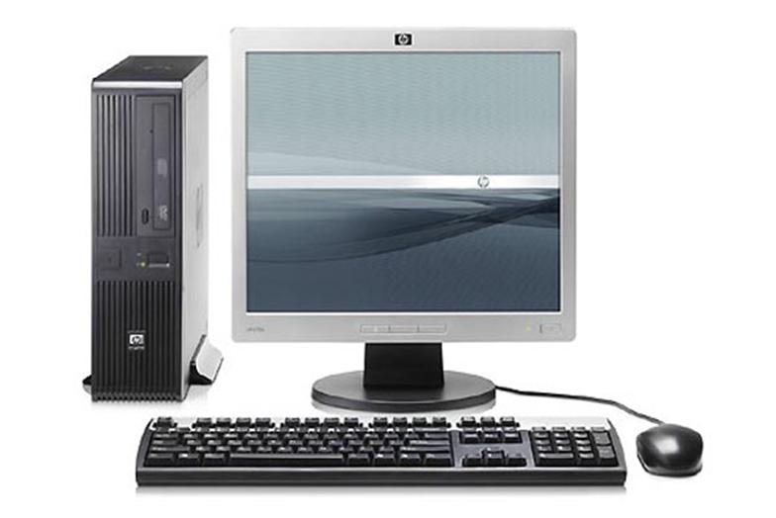

**5TH GENERATION ARTIFICIAL INTELLIGENCE (AI)**

**1980’S TO DATE**

Computer devices with artificial intelligence are still in development, but some of these technologies are beginning to emerge and being used such as voice recognition.

Artificial Intelligence (AI) is a reality made possible by using parallel processing and superconductors. Leaning to the future, computers will be radically transformed again by quantum computation, molecular and nano technology.

The essence of fifth generation will be using these technologies to ultimately create machines which can process and respond to natural language, and have capability to learn and organize themselves. They also have the capacity of making decisions and judgments.

This generation is witnessing the influx of super microcomputers through artificial intelligence whose main attraction over previous computers is speed and power.

These are computers that will be able to mimic many things that so far can only be done by human beings. For example, fifth generation computers will be able to accept spoken word instruction (voice recognition) and assist doctors in carrying out diagnosis.

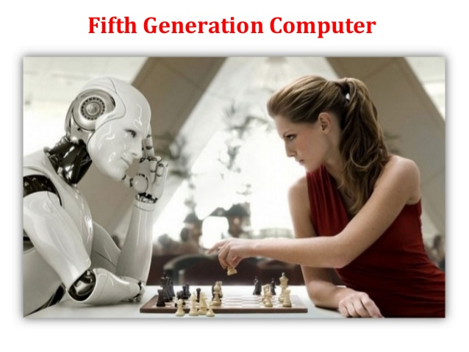

**ROBOTICS**

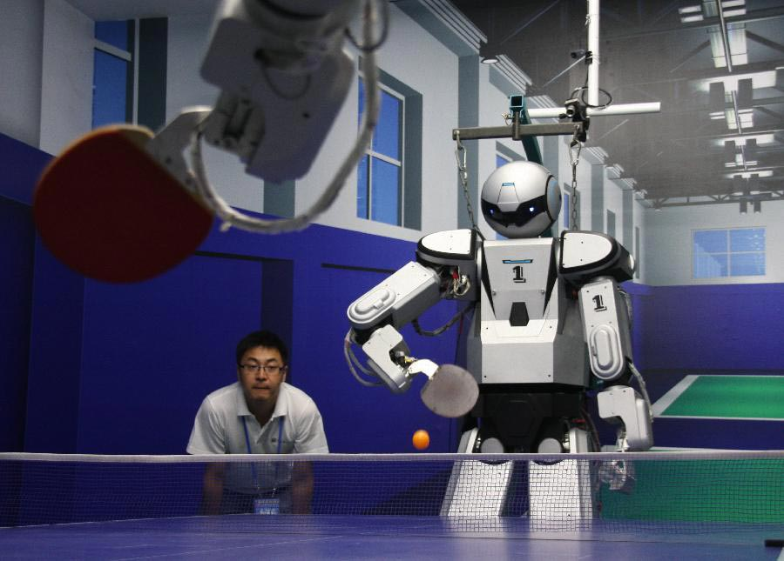

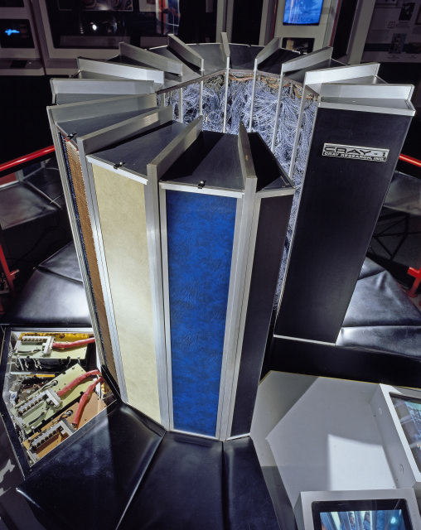

**CRAY 1**

**EVALUATION**

1. The fifth generation computers made use of ________________
2. The means by which a computer receives spoken word instruction is called

__________

3. The 3rd generation computers were manufactured between ___ and _____

4. List two characteristics of 3rd generation computers.

5. First generation computers were manufactured between __ and _____

6. One of the problems of the first generation computers was that they generate a lot of _________

7. ________ was used for storage in the 2nd generation computers.

8. List two examples of 2nd Generation computers.

9. What is a microprocessor?

**WEEKEND ASSIGNMENT**

1. We have ________ generations of computers.
2. 2 (b) 3 (c) 4 (d) 5
3. The characteristics of first generation computers include the following except ________________
4. They were very bulky and heavy.

(b) They measured between 50ft and 100ft long.

(c) The computers weighed up to 200 tons and occupied 3000 cubic ft.

(d) They used transistors to store and process data.

1. Fourth generation computers used __________
2. Vacuum tubes b. Transistors c. Artificial Intelligence
3. Very Large scale integrated circuits
4. _______ generation of computers used fibre optics

(a) First (b) Second (c) Fourth (d) Fifth

1. Second generation computers were _____ than 3rd generation of computers. (a) Smaller (b) Faster (c) More reliable (d) Slower

**ESSAY QUESTIONS:**

1. What do we mean by ‘generation of computers’?

2. Compare and contrast the characteristics of the 3rd and 4th generation computers.

**WEEK 7 (MID TERM HOLIDAY)**

**WEEK 8**

**TOPIC: DATA PROCESSING**

**CONTENT:**

1. Definition of data processing
2. Data processing cycle

**Definition of Data Processing**

**Data processing is the process of producing meaningful information b y collecting all items of data together and performing operations on them to extract information.**

**Data processing can also be described as a series of actions or operations that convert or manipulate data into useful information.**

Data processing involves the systematic recording, calculation, selection and combination of data to obtain facts and disseminate facts in relation to events in our everyday life. The processing of data can either be done manually or with the use of electronic machines. Data processing can involve calculating, sorting, editing etc.

**DATA PROCESSING CYCLE**

Data processing cycle includes the following:

1. **DATA GATHERING**

At this stage, data is gathered through various ways such as asking questions observations, reading books, listening and watching electronic media (radio and television). For example, giving a prospective customer a form to fill before opening a bank account is a form of data gathering.

1. **DATA COLLATION**

**This involves writing out, sorting, summarizing or classifying data into groups, structures or files. Data is sorted in a way that will make data processing easy**

Data collection is a term used to describe a process of preparing and collecting data. For example: as part of a process improvement or similar projection. The purpose of data collection is to obtain information to keep on record, to make decisions about important issues, to pass information on to other. Primarily, data is collected to provide information regarding a specific topic.

1. **INPUT STAGE:**

All information is entered into the computer through an input terminal (eg. mouse, keyboard, web camera etc). Input devices are devices that accept data in its original format, examples includes keyboard and mouse. Data is entered through input devices. This is the process through which collected data is transformed into a form that computer can understand. It is a very important step in the data processing cycle because correct output result totally depends on the input data.

**Three steps are involved when inputting data into the computer:**

1. **Collection:** thisrefers to gathering the data from a variety of sources and assembling it.
2. **Verification**: means checking the data to determine whether it is accurate and complete, and if it should be included for processing.
3. **Coding:**this is translating the data into machine-readable form. Data punched into IBM cards is one example of coding.
4. **PROCESSING STAGE:** During processing or manipulation, one or more of the following tasks may be performed on the input data.
5. ***Classifying*:** data are organized by characteristics meaningful to the user. For example, a student may be identified by the admission number and class.
6. ***Sorting*:** in this step, the data may be arranged in a particular sequence to facilitate processing.
7. ***Calculating*:** Calculations may be required to determine a patient’s account balance or a student’s grade point average.
8. ***Summarizing:*** This involves reducing a large document into a smaller size containing important points.

**At this particular stage, data is converted (processed) into information.**

1. **STORAGE STAGE:**

All computers need to store and retrieve data for processing. Storage can be grouped into two categories **primary storage and secondary storage**.

1. ***Primary Storage***: the primary storage, also called main memory or Immediate Access Store (IMAS), resides in the computer. This is necessary since the processing unit can only act on data and instructions that are held in primary storage. Primary storage consists of two types of memory chips. These are Random Access Memory (RAM) and Read Only Memory (ROM) chips.
2. ***Secondary Storage*:** This is needed to store data and information on a permanent basis for later use. Examples of secondary storage devices are floppy disk, hard disk, zip drives, flash drives etc.
3. **OUTPUT STAGE:**

After completing the processing step, output is generated. The result of the data processed is printed out from the printer. Mostly, the output is stored on the storage media for later use. **If the output result is accurate, the data processing cycle is completed.**

**Output activities include the following;**

1. ***Retrieving:*** involves pulling information from storage device for use by the decision-maker.
2. ***Converting:*** means translating information from the computer form used to store it, to a form understandable by the user (such as, a CRT display or printed report).
3. ***Storing:*** involves transferring the data onto a storage medium, such as a disk or tape file for future use.
4. ***Communication:*** takes place when the relevant accurate information is in the right place at the right time.

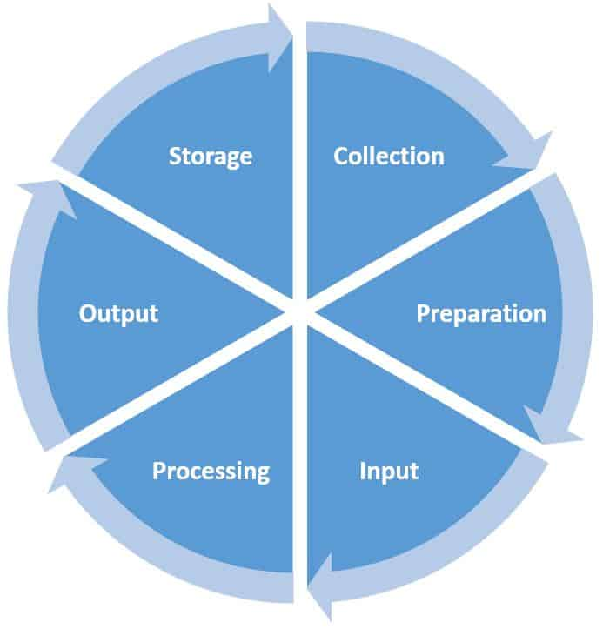

**EVALUATION:**

1. What is data processing?
2. List and explain the stages involved in data processing.
3. What is the condition that makes data processing complete?

**READING ASSIGNMENT:**

Browse the Internet for Importance of Computer in Data processing

**WEEKEND ASSIGNMENT:**

1. Data gathering involves ___________
2. Sourcing for data
3. Analyzing data
4. Summarizing data
5. Editing data
6. The stage at which data is manipulated is called ___________
7. Data collection (b) Input stage

(c) Processing stage (d) Output stage

1. To store data on a permanent basis is called ____________
2. Permanent storage (b) Primary storage

(c) Secondary storage (d) First storage

1. Data preparation involves the following except ____________
2. Sorting (b) classifying (c) processing data (d) summarizing
3. _______ devices receive data in its original format
4. Output (b) input (c) storage (d) processing
5. _______ are the raw material or input to the computer.
6. Input (b) data (c) words (d) documents
7. The three stages of data processing is _____, ________ and _________.
8. Processing (b) input (c) output (d) classifying
9. The two steps involved in inputting data into the computer are _______ and _______.
10. Collection (b) sorting (c) coding (d) Analyzing
11. _______means checking the data to see whether it is accurate or complete.
12. Coding (b) coding (c) Verification (d) Manipulation
13. _______ is translating the data into machine-readable form.

Input (b) coding (c) processing (d) checking

**WEEK 9**

**TOPIC: DATA PROCESSING**

**CONTENT:**

**IMPORTANCE OF THE COMPUTER AS A TOOL FOR DATA PROCESSING**

The computer is a very unique electronic device and has certain features and characteristics that distinguish it from other machines. These include:

1. **Speed** – Computers are very fast; they can perform tens of millions of operations per second. This is necessary for predicting weather forecasts, performing scientific research and even producing thousands of bills for utility companies.
2. **Accuracy**– computers are very accurate. Errors only occur if there is an error in hardware, software or data. When errors occur it is usually because of some human error, since computers can only do what they are programmed to do.
3. ***Storing large amounts of information in a small space*** – there are many storage media that can be used to store large volumes of data and information. For example, a single CD-ROM disk can save the equivalent of a shelf of books in the library.
4. **Working continuously** – computers can work continuously for long periods without much maintenance.
5. **Quality** – The type of output produced by the computer is far better than other electronic machines. Document is best prepared by the use of the computers.
6. **Control and consistency** – the computer has automatic control and can operate for a very long time without getting exhausted. This is because a computer works under the guide of a program, and has an in-built cooling fan, or heat sink that makes it work all day long.
7. **Reliability:** the computer responds to the instruction keyed into it without any alteration, as a result of this, it gives no room for doubt over output. Therefore, the operator relies on it for effectiveness.  
   Example include a program computer device to ring alarm to alert workers of any emergency, a programmed entry and exit door used in big companies and supermarkets, offices, etc.
8. ***Versatility*:** The computer is used in different fields of human endeavour ranging from business, education, technology, engineering, law, commerce, agriculture, medicine, sports, etc. It can perform different types of tasks provided such tasks can be stated in logical way for the computer to execute. The computer is used to type letters, watch films, play music, etc.
9. ***Large Storage Capacity*:** vast quantities of data stored in paper files would become extremely bulky and require substantial storage space. Furthermore, the job of manually extracting data from such files would  
   become increasingly tedious and time consuming as the size of the files increases. But with the computer, data can be stored electronically in considerable less space, and retrieve in a fraction of the time needed  
   by the manual method. The ability of the computer to store, retrieve and process data, all without human intervention gives it power and advantage over that of human beings. So, while human can perform the same function as the computer, the difference and major benefits is that the computer can reliably execute millions of instructions in a second and stored the result in an almost unlimited memory.
10. **Programmability:** The computer can be programmed to do all forms of activities of man so long as the task is reduced to a series of logical steps. Programming in computer means the act of writing computer programs and this involves the use of special set of  
    characters, signs, symbols, to supply instruction to the computer for execution towards achieving specific tasks (motives). This opportunity gave room for the computer to be a versatile system.

**EVALUATION:**

1. What are the different features that make the computer an excellent tool for data processing?
2. Explain what it means for a computer to be versatility
3. Can computers make mistake? No/Yes? Give reasons for your answer

**READING ASSIGNMENT:**

Lay your hands on the Use Mavis Beacon for typing.

**WEEKEND ASSIGNMENT:**

1. The characteristic of the computer that makes it to carry out various activities is called ___________
2. Versatility (b) Accuracy (c) Speed (d) Consistency
3. Computers can work continuously for a long time.
4. True (b) False (c) Sometimes (d) Always
5. Some places the computer can be used include the following except ___________

(a) Hospitals (b) Street (c) Market (d) Schools

1. The computer works under the guide of __________
2. Human beings (b) Control unit

(c) A program (d) a keyboard

1. Can computers make mistake? _______________
2. Yes (b) No (c) Sometimes (d) Always